# Heuristic

User interface should be consistent through out the game, by keeping the same meaning to same symbols and words.

# Analysis

The game has failed to follow consistent meanings throughout the game, as the game is changing style of Heads Up Display(HUD) and is changing meaning of symbols depending on the level or changes style of User Interface(UI) depending on the level.

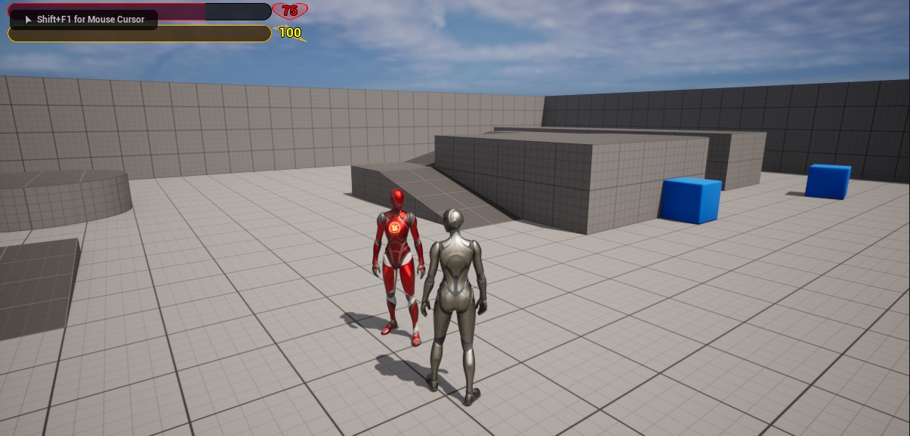The first example is of Main Menu(MM). This is the first screen visible to the player which sets the outline of what style of UI will be present through out the game. Ignoring the obviously mistakes like, the buttons not aligning or the title not being in correct place, the overall dark tone that sets the mood using lightning is also only present in MM.

Example from gameplay shows us that mood changes and HUD based of MM’s UI is using different style. This different style uses alpha to make UI more transparent making it look more futuristic and minimalistic at the game time. Use of symbols to indicate what the bar means using recognition over recall as well as outline over the numbers makes it easy to tell how much health and stamina the A picture containing graphical user interface
player has.

# Suggested fixes

Seeing that HUD is done better than MM it is recommended to make changes to MM’s UI. These changes should follow the minimalistic style from the level, making the buttons partially transparent and futuristic looking. There should also be aligned and the text on the outlined to be easier to read.

Here is an example on how one UI could look like. With title and buttons aligned and minimalistic.

Secondary problem identified is mood set through colors in lightning not matching MM and the level. This could be solved by changing the lightning in the level to make is just as dark and moody.